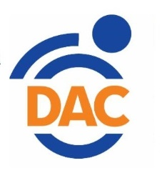
Vision Support Group
Second Thursday every month at 2 pm
Contact AJ at 530-242-8550 Redding
Or Greg 530-893-8527 Chico
For more information or for zoom info

Disability Action Center
2440 Athens Ave., Redding, CA 96001
(530) 242-8550
www.actionctr.org
Vision Resources & Support
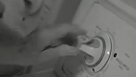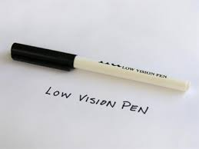

Serving: Butte, Glenn, Lassen, Modoc, Plumas, Shasta, Siskiyou and Tehama counties
We provide FREE services to visually impaired individuals in 8 counties of Northern California. Our Program seeks to stimulate independent living, empowerment and full inclusion of individuals who are visually impaired.

